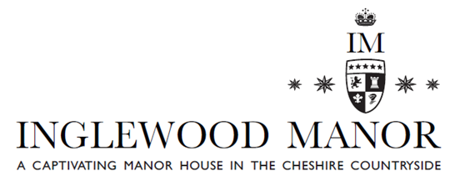

Afternoon Tea

Selection of sandwiches on wholemeal and white bread with the following fillings

Smoked Applewood cheddar apple raisin and cider chutney
Honey roast Ham with wholegrain mustard and tomato
Free range egg mayonnaise with watercress v
Tuna mayonnaise with cucumber

SELECTION OF HOME MADE CAKES INCLUDING:

Fruit scone with clotted cream and Selection of Jams

Chocolate brownie with candied orange peel

Lemon posset blueberry compote

Classic Victoria sponge

Carrot cake cinnamon butter cream, candied pecan nut

(V) Suitable for vegetarians. All products may contain nuts, seeds, gluten or other allergens.
Food allergies and intolerances: please inform your server before ordering if you have a food allergy or intolerance. All food is prepared in an area where allergens are present

